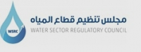

Survey Report:
Waste Water

Establishment and operation of the Water Sector Regulatory Council
(Wastewater and Desalination Monitoring Program)
Palestine: West Bank and Gaza Strip
Framework Contract EuropeAid/127054/C/SER/Multi
Lot 6: Environment
Letter of Contract N° 2016/374056

Project implemented by
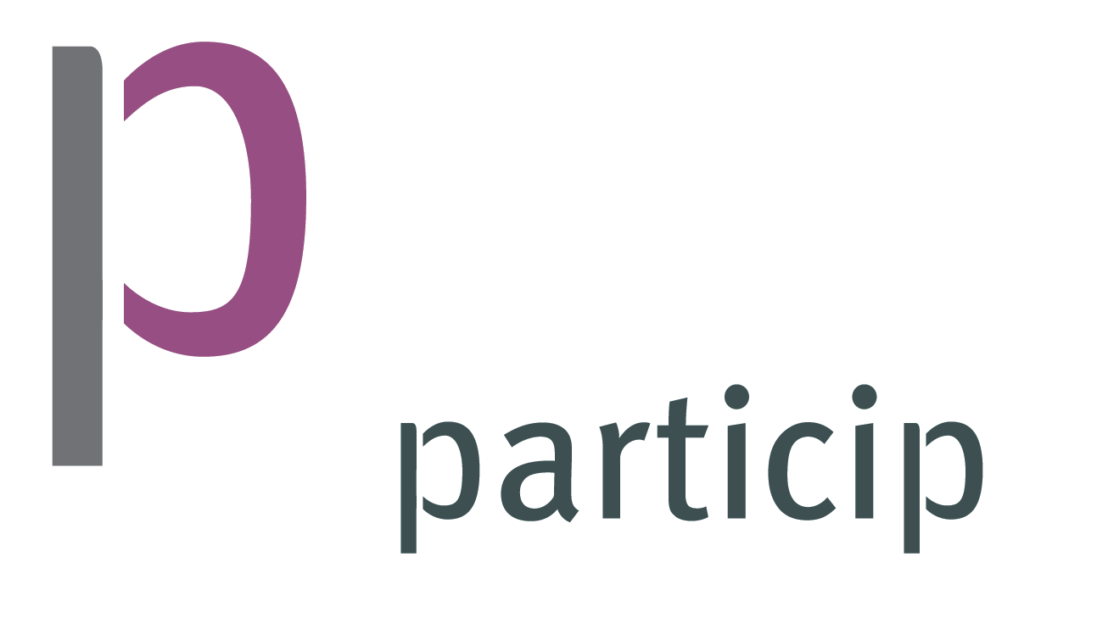

Particip-led Consortium comprising: Particip, Adelphi, AETS, Bipro, ELLE, ETI Consulting, Geotest, HTSPE, Milieu, NIRAS, PEMConsult, Poseidon

March 2017

Table of Contents
Acronyms and Abbreviations 6
1. Introduction 7
1.1 Background 7
1.2 Objectives of baseline study 7
1.3 Survey Report Components 8
2. Study Plan and Methodology 9
2.1 Introduction 9
2.2 Survey implementation 9
2.3 Survey and data Collection limitations 9
2.4 Challenges and Difficulties 9
2.5 Raw Data 10
3. Service Providers (SPs) 11
3.1 WW Service Providers in West Bank and Gaza Strip 11
3.2 Service Providers Categorization 13
3.3 SPs WW Organization Structure and strategic plans 14
3.4 Wastewater SPs Employees 16
3.5 Complaints System and Emergency Calls 17
3.6 Capacity Building and Training 18
4. Wastewater in West Bank and Gaza 23
4.1 Introduction 23
4.2 Wastewater Generated Quantity 23
4.3 Inventory of Wastewater network 24
4.5 Pressurized Sewer network and Pumps 30
5. Wastewater Treatment Plants in West bank and Gaza 33
5.1 The Status of Wastewater Treatment in Palestine 33
5.2 Treated Wastewater In Palestine 35
5.3 Survey and baseline data of WWTP in Palestine 36
5.3.1 Activated Sludge WWTPs 36
5.3.2 Hybrid WWTPs 40
5.3.3 Anaerobic/ Aerobic Stabilization Ponds WWTPs 41
5.3.4 Membrane Bioreactors (MBR) WWTP 43
5.3.5 Constructed Wet lands WWTPs 43
5.3.6 RPC WWTP 44
5.3.7 Sedimentation Tank WWTP 45
5.4 WWTP Interruption and Overflow 45
5.5 Sludge produced and utilized 47
5.6 Energy Consumption (KW/year) 48
6. Water Reuse in Palestine 49
6.1 Introduction 49
6.2 Reuse system 50
7. Tariff and Financial Status 52
7.1 Wastewater Tariff 52
7.2 Wastewater Revenue 55
7.3 Wastewater Treatment Costs 56
7.4 WW Assets 57
8. Key Findings 58
Annex – 1: Questionnaire 59

List of Figures
Figure 1: Technical Raw Data Screen Shot 10
Figure 2: Financial Raw Data Screen Shot 10
Figure 3: Institutional Frameworks of WW SPs 11
Figure 4: WW SPs in West bank 12
Figure 5: WW SPs Distribution in West bank 13
Figure 6: WW SPs category in West bank and Gaza 14
Figure 7: WW SPs responds to Organization structure 15
Figure 8: WW SPs responds to availability of Strategic Plan 15
Figure 9: Part time/ full time employees as well as the sewer and WWTP employees. 16
Figure 10: Employees of WW SPs in West bank and Gaza 17
Figure 11: Complaints System status for WW SPs in West bank and Gaza 17
Figure 12: Categorize of Complaints for WW SPs in West bank and Gaza 18
Figure 13: Nr. of training Delivered 18
Figure 14: Sewer network condition in West bank and Gaza 23
Figure 15: Wastewater Services History in West Bank and Gaza 25
Figure 16: Sewer network percentage diameter in West Bank 25
Figure 17: Sewer network length/diameter in West Bank 26
Figure 18: Type of Sewer Collection 27
Figure 19: 2015 New House Connection in West Bank and Gaza 28
Figure 20: Suction Tanks Discharge 29
Figure 21: Sewer Network Discharge 30
Figure 22: Sewer Network system in West Bank and Gaza 30
Figure 23: Sewer Network pumps location in West Bank and Gaza 32
Figure 24: Types of Municipal Wastewater Treatment Plants in Palestine 33
Figure 25: Key map for WWTP locations in West Bank and Gaza 34
Figure 26: Weighted average of WWTP technologies in term of treated wastewater quantity 35
Figure 27: Wastewater collected vs Wastewater treated in West bank and Gaza 35
Figure 28: Nablus West WWTP (Source: http://wwtpal.com/) 36
Figure 29: Jericho WWTP Overview 37
Figure 30: Al Bireh WWTP Overview 37
Figure 31: Al Bireh WWTP Rehabilitation project in 2015 38
Figure 32: Anza WWTP Activated Sludge Treatment 38
Figure 33: O&M Cost for Activated Sludge Treatment 39
Figure 34: Aeration Pond at Gaza WWTP 40
Figure 35: Rafah WWTP 40
Figure 36: O&M Cost for Hybrid System Treatment 41
Figure 37: O&M Cost for Hybrid System Treatment 42
Figure 38: O&M Cost for Anaerobic/ Aerobic Stabilization Ponds 43
Figure 39: Beit Hassan Wet land WWTP 44
Figure 40: O&M Sedimentation Tank Cost 45
Figure 41: Nr of Overflow Occurs in 2015 46
Figure 42: Nr Interruption affected the WWTPs 46
Figure 43: Dry Sludge produced in West Bank WWTPs 48
Figure 44: Sludge management in West Bank WWTPs 48
Figure 45: energy Consumption in West Bank WWTPs 49
Figure 46: Energy Consumption in West Bank WWTPs 49
Figure 47: Reuse System for treated WW 51
Figure 48: Treated Wastewater reuse and farmers 51
Figure 49: Treated Wastewater reuse and farmers 52
Figure 50: WW Tariff in West bank 52
Figure 51: Connection Fees differentiation between the SPs 54
Figure 52: Total service revenue vs the total billed amount 55
Figure 53: Connection Fees Revenue 56
Figure 54: WW service classification in term of Cost 56
Figure 55: WW service classification for SPs in term of Cost 57
Figure 56: WW Assets in West Bank 57

List of Tables
Table 1: General Information about WW Service Providers in West bank and Gaza 19
Table 2: WW Service Provider Reuse System 50
Table 3: WW Service Provider with no WW Tariff service 53

Acronyms and Abbreviations
CMWU: Coastal Municipalities Water Utility
EU: European Union
GDP: Gross Domestic Product
ILS: Israeli Shekel
JWU: Jerusalem water Undertaking
KPIs: Key Performance Indicators
KWm: Kilowatt meter
MBR: Membrane Batch Reactor
MCM: Million Cubic Meter
NGOs: Non-governmental organisations
NWC: National Water Company
O&M: Operation and Maintenance
PNA: Palestinian National Authority
PSI: Palestinian Standard Institute
PWA: Palestinian Water Authority
PWA: Palestinian Water Authority
RBC: Rotating Biological Contactors
RO: Reverse Osmosis
TC: Total coliform
TDS: Total Dissolved Solids
UNICEF: United Nations Children's Emergency Fund
USAID: United States Agency for International Development
WHO: World Health Organization
WSRC: Water Sector Regulatory Council
WSSA: Water Supply and Sanitation Authority
WW: Wastewater
WWSPs: Wastewater Service Providers
WWTP: Wastewater Treatment Plant

1. Introduction

1.1 Background
On December 14th 2009, the Cabinet of Ministers of the Palestinian National Authority (PNA) endorsed the “Action Plan for Reform” towards the definition and implementation of a comprehensive program of institutional and legislative reform in the Palestinian water sector. The establishment of a Water Regulatory Council was proposed.
The 2014 Water Law has established the WSRC. The overall aim of the WSRC is to ensure water and wastewater service quality and efficiency to consumers in Palestine at affordable prices. The WSRC is to monitor operational processes related to water and the operational processes of wastewater management including wastewater collection, treatment and disposal, and reuse of treated wastewater for irrigation.
Among the other tools that are still to be completed before full readiness of WSRC include the establishment of baseline data and situational report on the operational processes of water and wastewater services.
The WSRC has already prepared a number of tools for water related activities, but not for wastewater or desalination operations. In addition, the Council has not set the necessary quality standards.
The specific objectives of the consultancy assignment “Establishment and operation of the WSRC (Wastewater and desalination monitoring program)” is to:
- Conduct a baseline survey on the existing wastewater and desalination systems and operations in Palestine
- Develop monitoring indicators, tools and procedures for wastewater and desalination in Palestine
This baseline survey covers the wastewater service providers for both West Bank and Gaza.

1.2 Objectives of baseline study
The study incorporates survey report of environmental engineering discipline to bring about further insight to the remediation of technology selection failure. The main objectives of the study include the following:
- Technical and financial survey of existing and current wastewater system including the WWTP technologies applied in Palestine.
- Identification and inventory analysis of WW service providers in West bank and Gaza.
- Analyze and evaluate energy costs for each wastewater treatment and revenue of the service.
The finding from this study is expected to bring and develop a monitoring indicators, tools and procedures for wastewater in Palestine.

1.3 Survey Report Components
The major WW Survey report components are:
- Survey Methodology – A survey camping which collected data from WW SPs in West bank and Gaza.
- Raw Data – A raw data for the collected data in the shape of excel files for the all the WW SPs in West Bank and Gaza.
- Statistic Figures and Charts.
- Comparison Figures and Charts between selected WW SPs.
- Key findings.

2. Study Plan and Methodology

2.1 Introduction
The baseline survey as part of this consultancy assignment was applied to all WW SPs that operate and provide wastewater services. The total number of SPs covered in the survey study is 73. This figure includes 105 community served by these service providers. A separate visit and interview has been conducted for all these service providers.
The study converts the variables and indicators into data collection tools in the field study such as questionnaire, interview and observation. These data collection tools have been tested that it fulfills all the required data to calculate and measure the required indicators and variables.

2.2 Survey implementation
The survey covered all WW SPs in West Bank and Gaza. Questionnaire development, survey method design, staff preparation, and survey implementation were all undertaken.
The survey was conducted from October 2016 to first of January 2017 covering the year of 2015. Most of the Service providers has been visited at least once except some communities which cannot be visited without a permit. The data and information from these communities were collected by Telephone and e-mails.

2.3 Survey and data Collection limitations
The survey questionnaire was designed based on the proposed indicators which are related to different information and data such WWTP, reuse, etc. Some information was Not Applicable due to the fact that some WW SPs do not have a WWTP.
Also, some information and data were estimated since some WW SPs do not have a documented or measured data. For example, wastewater quantity was estimated based on the water consumption. For the financial date, it is important to note that most of the SPs do not separate between the water and wastewater services in term of accounting and/or employers.

2.4 Challenges and Difficulties
It is important to state that 80% of survey within 2 month covering 60 service providers. Some difficulties were noted that delayed the completion of survey. The major difficulties are:
- The proposed indicators and its related data requires different type of experts from the same institute. This impacted and delayed the fixation of the interviews and visits in some case. On other case, the survey team visited the same SPs two or three times.
- Some municipalities were visited several times such as the Municipalities of Ramallah, Nablus, Tulkarem etc. For example, Nablus municipality was visited 8 times, Ramallah 5 times and Tulkarem 5 times.
- Lack of information and experts in municipalities and refugee camps.
- It was very difficult to get the information of the financial questionnaire in December due to the preoccupation of accounting and finical department with preparation of the budgets for the new year.
- Small WW SPs, do not have any background about WSRC.

2.5 Raw Data
All the collected Data and information has been organized in an excel sheets format. Each cell has a information and a input massage to give the meaning of the information and/or justification for input data.
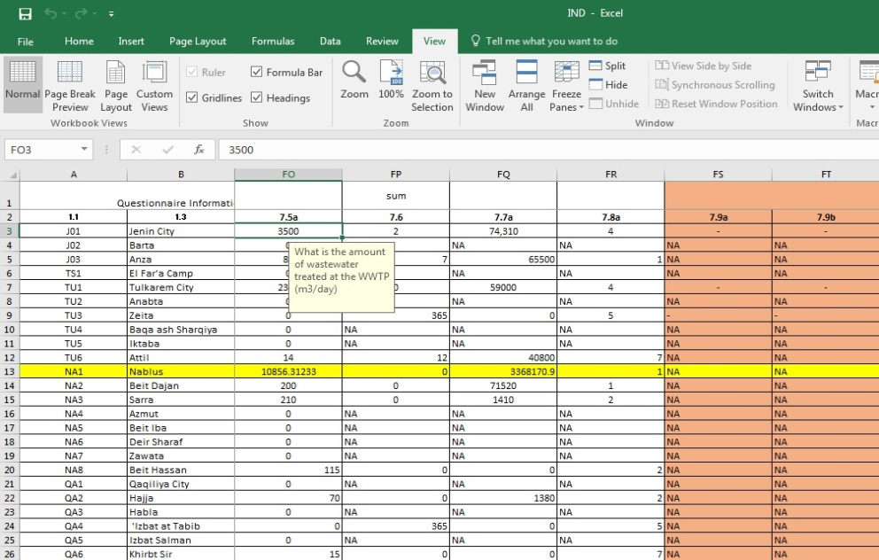
Figure 1: Technical Raw Data Screen Shot
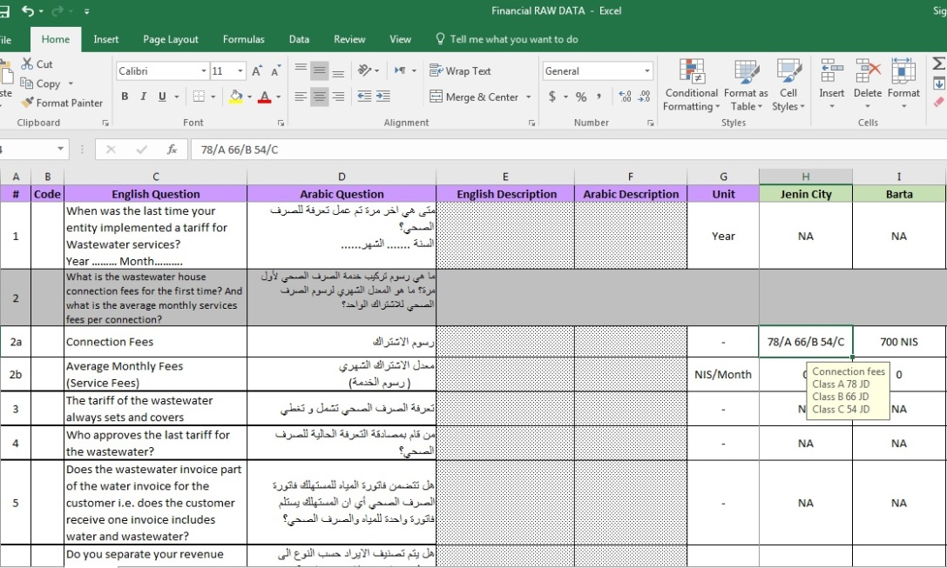
Figure 2: Financial Raw Data Screen Shot

3. Service Providers (SPs)

3.1 WW Service Providers in West Bank and Gaza Strip
According to the survey conducted under this project, there are 73 WW service providers in West Bank and Gaza in the form of utilities, departments within municipalities, village and joint service councils. This report covers all the 54 SPs in West Bank and the 19 SPs in Gaza Strip operating up to 31st of December 2016.
By the end of 2019, the expected number of new SPs is 8. These are Tubas JSC (West and East), Salfit, Hebron, Beit lid, Beit Wazan, Ramen and Rawabi.
Service providers are operating under different institutional frameworks. Most of these SPs are operating and works under the Municipality’s as separate department or within the engineering department. In the West Bank, Water Supply and Sewerage Authority in Bethlehem (WSSA) is the only utility that provides the wastewater services. The Coastal Municipal Water Utility (CMWU) is the only utility in Gaza strip. Figure 3 shows the institutional classification of the WW service provides.

Figure 3: Institutional Frameworks of WW SPs
The WW SPs includes 40 municipalities, 25 village Council, 5 Refugee Camps, 2 utilities and one JSC. The following map in Figure 4 show the West Bank service providers with the indicative area of each.
Most of these service providers are operating sewer network only. The total number of SPs operating sewer network without operating WWTP is 46. While, only 27 are providing the service of operation and maintenance of both sewer network and WWTP. This result and statement does not mean that there are 46 source point pollution and outfall dumping to wadis as some SPs have a limit of operation up to the WWTP which is operated by other party or SP.
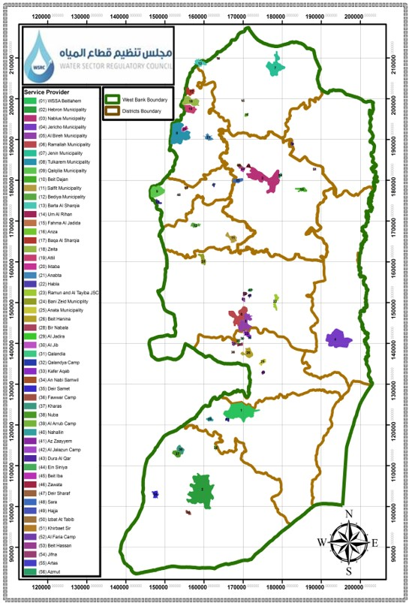
Figure 4: WW SPs in West bank
The SPs are distributed in different districts in West Bank. Figure 5 shows distribution of the Service providers among the districts in West Bank.
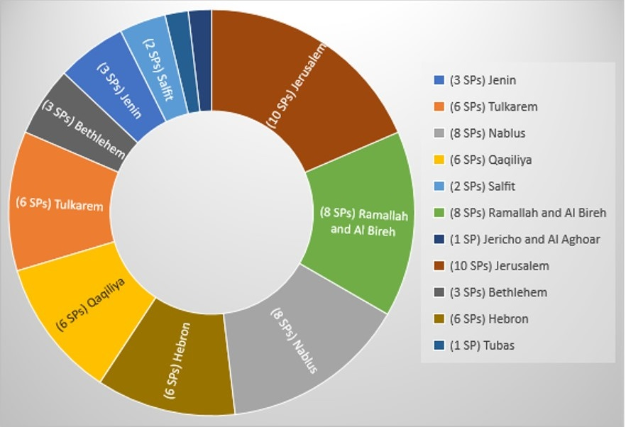
Figure 5: WW SPs Distribution in West bank
The general information on WW SPs covered in this report for year 2015 is presented in Table 1.

3.2 Service Providers Categorization
In West Bank and Gaza, there are three type of WW SPs based on the service provided by the instate. These are:
- WW SPs that operate Sewer Network and WWTP.
- WW SPs that operate only a Sewer Network.
- WW SPs that operate only a WWTP
In Palestine, there is no regional wastewater service providers. But, there are some cases where several SPs treat their wastewater in one WWTP operated by only one SP. Figure 6 shows the percentage of each category.
The number of WW SPs with sewer network and WWTP is 30 while 40 WW SPs provide the service of Sewer Network. And three service provides only wastewater treatment service.

Figure 6: WW SPs category in West bank and Gaza

3.3 SPs WW Organization Structure and strategic plans
Slightly more than a half or our sample consisting of 73 respondents said their institute didn’t have an organization structure approved by local government,
While 83% of the respondents said that their institute didn’t have a wastewater division and they are working under the engineering department or working without any WW job descriptions for the employees.
As shown in Figure 9 only 40.28% of the respondents said their institutes have strategic plans for the wastewater management, and while all the 19 service providers in Gaza have confirmed the existence of a strategic plans for wastewater management, only 19% of the 54 service providers in the West Bank confirmed the existence of such plans. And when asked about the cooperation and coordination between the SP and any entity (government and nongovernment organizations) and other sanitation services, all the service providers in the Gaza stated that they have cooperated/ coordinated with other entities including, the most frequent entities that have worked with the SP’s in Gaza were CMWU and PWA while UNRWA, MDLF, KFW and ANERA had worked with less frequency. In the West Bank only 3 service providers have stated that they cooperated/coordinated with other entities, in which all 3 have worked with Kfw representing only 6% of the West Bank SP’s.

Figure 8: WW SPs responds to Organization structure

Figure 9: WW SPs responds to availability of Strategic Plan

3.4 Wastewater SPs Employees
The total number of employees working in the field of WW within the SPs is 576. This number includes full and part time administrative, workers, technicians and operators of sewer network and WWTP. The number of part time employees is 53. Figure 10 shows the percentage of part time/ full time employees as well as the sewer and WWTP employees.
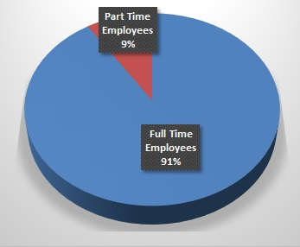
Figure 10: Part time/ full time employees as well as the sewer and WWTP employees.

The number of administrative employees is 101. This includes the engineers and other management employees. The number of technician and operator are 104 and 35 respectively. The total number of workers is 336. Figure 11 shows the percentage of employees with respect to job description.
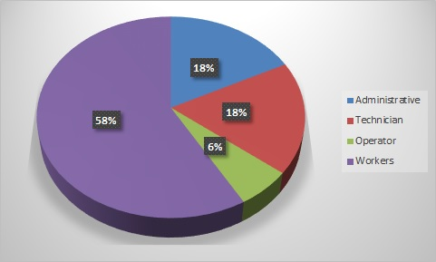
Figure 11: Employees of WW SPs in West bank and Gaza
The total number of female employees is 7. All of them are administrative employees which represent 8% of total administrative employees.

3.5 Complaints System and Emergency Calls
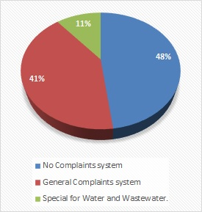
Figure 12: Complaints System status for WW SPs in West bank and Gaza
In General, most of the WW SPs do not have a special complaints system for wastewater service. It is either part of general complaints system of the institute or part of the water service complaints system.
Only 7 WW Service providers have a special complaints system that records and document the complaints received by the customers. 35 WW service providers do not have a complaints system or a record. 30 WW service providers have a general complains system. See Figure 12.
The absence of complaints system has been noted in small WW SPs. They use emergency calls system only to deal with urgent maintenance issues. On the other hand, most of SPs with general complaints system do not have records for WW complaints, but when analyzing the responses of the SP’s of Gaza and the West Bank separately, almost all the service provides in Gaza have an established complaint system either a general system (84% of Gaza’s SP’s) or water/wastewater system (11% of Gaza’s SP’s). In the West Bank the situation is reversed as 64% of the West Bank SP’s had no complaint system,26% have a general complaint system and only 9% of the SP’s in the West Bank have stated that they have a water/wastewater complaint system.
The total number of complaints recorded in 2015 for West Bank and Gaza is 55,631. The only categorized compliant are 15776. Figure 13 shows the categories of the recorder complaints.

Figure 13: Categorize of Complaints for WW SPs in West bank and Gaza
The rest of complaints are recorded but without any categorization. All WW SPs claimed that the responds time for flood complaints is 24 hours. the number of complaints solved is 49619.
The total number of emergency calls received in 2015 is 20,243. All of them are emergence calls for flooding of sewerage form sewer manhole and/or broken manhole. The respond time is 24 hour for all.

3.6 Capacity Building and Training
There were no actual records for training of employers at WW SPs. Most of the information are related to what the respondents remember. The total number of related training in 2015 is 76. Most of these are administrative trainings for engineers.
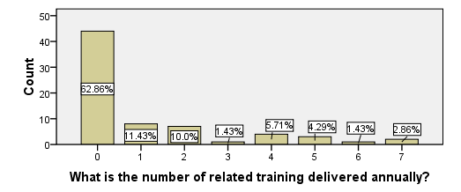
Figure 14: Number. of training Delivered
Regarding annual trainings held, 62.86% of the respondents said they didn’t deliver related training while the rest have reported trainings with percentages as in Figure 14.

Table 1: General Information about WW Service Providers in West bank and Gaza
WW Service Provider | No. of Served Communities | Population |  | Wastewater Collected in network (m³/year) | WWTP Service | Waste Water Service
 |  | Total (2015) | Served |  |  | No. of House Connection | Length of Sewer Network (Km) | Coverage (%)
West Bank SPs
Jenin Municipality (WSSD) | 2 | 59,883 | 41918 | 993,530 | √ | 2,029 | 89,575 | 70.00%
Barta Municipality (ED) | 1 | 5,065 | 4052 | 170,082 | X | 0 | 10,771 | 80.00%
Anza Village Council | 1 | 2400 | 2280 | 32,850 | √ | 320 | 9,500 | 95.00%
El Far'a Camp | 1 | 7335 | 2934 | 80,318 | X | 443 | 5500 | 40.00%
Tulkarem Municipality (WSSD) | 3 | 78842 | 35479 | 854,100 | √ | 1780 | 108,600 | 45.00%
Anabta Municipality (WSSD) | 1 | 8445 | 4223 | 229,950 | X | 1000 | 13,200 | 50.00%
Zeita Municipality (ED) | 1 | 3286 | 2957 | 29,200 | √ | 650 | 10,620 | 90.00%
Baqa ash Sharqiya Municipality (ED) | 1 | 4726 | 2836 | 109,500 | X | 576 | 18,500 | 60.00%
Iktaba Village Council | 1 | 3071 | 31 | 1,825 | X | 3 | 2,850 | 1.00%
Attil Municipality (ED) | 1 | 10415 | 260 | 14730 | √ | 70 | 1,900 | 2.5%
Nablus Municipality (WSSD) | 5 | 189000 | 183330 | 7,300,000 | √ | 35000 | 235,175 | 97.00%
Beit Dajan Village Council | 1 | 4138 | 2897 | 73,000 | √ | 388 | 14,970 | 70.00%
Sarra Village Council | 1 | 3040 | 2949 | 76,650 | √ | 340 | 12,000 | 97.00%
Azmut Village Council | 1 | 3147 | 1888 | 65,700 | X | 345 | 4,500 | 60.00%
Beit Iba Village Council | 1 | 3740 | 3366 | 109,500 | X | 625 | 6,800 | 90.00%
Deir Sharaf Village Council | 1 | 2921 | 2045 | 56,575 | X | 490 | 5,000 | 70.00%
Zawata Village Council | 1 | 2226 | 1690 | 47,450 | X | 300 | 3,650 | 76.00%
Beit Hassan Village Council | 1 | 1331 | 666 | 143,080 | √ | 150 | 2,500 | 50.00%
Qalqilia Municipality (WSSD) | 1 | 50700 | 49686 | 2,372,500 | X | 11951 | 106,172 | 98.00%
Hajja Village Council | 1 | 2609 | 1357 | 25,550 | √ | 150 | 3,500 | 52.00%
Habla Village Council | 1 | 7308 | 6577 | 267,545 | X | 1400 | 13,000 | 90.00%
'Izbat at Tabib Village Council | 1 | 281 | 169 | 9,855 | √ | 38 | 500 | 60.00%
Izbat Salman Village Council | 1 | 877 | 833 | 29,200 | X | 120 | 4,500 | 95.00%
Khirbt Sir Village Council | 1 | 902 | 216 | 5,475 | √ | 45 | 1,750 | 24.00%
Salfeet Municipality (WSSD) | 1 | 10443 | 6266 | 127,750 | X | 970 | 45,000 | 60.00%
Bediya Municipality (ED) | 1 | 9574 | 287 | 10,767 | √ | 84 | 3,150 | 3.00%
Ramallah Municipality (WSSD) | 1 | 34173 | 29389 | 1,642,500 | √ | 8000 | 100,000 | 86.00%
Al Bireh Municipality (WSSD) | 3 | 47,540 | 44212 | 2,190,000 | √ | 9790 | 90,210 | 93.00%
Ramoun and Al Taypa JSC | 2 | 5075 | 2538 | 12775 | √ | 110 | 12200 | 50.00%
Bani Zeid Al Gharbiya Municipality (ED) | 1 | 6863 | 206 | 8030 | √ | 67 | 4000 | 3.00%
Ein Siniya Village Council | 1 | 885 | 177 | 5475 | √ | 35 | 1000 | 20.00%
Jalazun Camp | 1 | 9723 | 9723 | 127750 | X | 1119 | 5300 | 100.00%
Dura El Qare Village Council | 1 | 3065 | 920 | 17520 | X | 100 | 1000 | 30.00%
Jifna Village Council | 1 | 2135 | 107 | 2920 | X | 20 | 1200 | 5.00%
Jericho Municipality (WSSD) | 1 | 22609 | 9044 | 200750 | √ | 772 | 55000 | 40.00%
Al Ram Municipality (ED) | 1 | 61000 | 25010 | 894250 | X | 4800 | 23870 | 41.00%
Bir Nabala Village Council | 1 | 5533 | 5367 | 215350 | X | 1050 | 12000 | 97.00%
Qalandiya Village Council | 1 | 1354 | 948 | 27375 | X | 160 | 2500 | 70.00%
Qalandiya Camp | 1 | 10144 | 9941 | 346750 | X | 1800 | 7200 | 98.00%
Beit Hanina Village Council | 1 | 1230 | 369 | 12775 | X | 75 | 2000 | 30.00%
Anata Municipality (ED) | 1 | 13840 | 13148 | 511000 | X | 2600 | 10000 | 95.00%
Al Judeira Village Council | 1 | 2614 | 1934 | 80300 | X | 350 | 4700 | 74.00%
Al Jib Village Council | 1 | 4847 | 3732 | 78475 | X | 325 | 4500 | 77.00%
An Nabi Samwil Village Council | 1 | 296 | 219 | 3650 | X | 22 | 800 | 74.00%
Az Za'ayyem Village Council | 1 | 3908 | 2540 | 54750 | X | 350 | 2500 | 65.00%
WSSA Bethlehem | 8 | 90000 | 54000 | 2190000 | X | 6500 | 242000 | 60.00%
Artas Village Council | 1 | 4492 | 3594 | 73000 | X | 500 | 4802 | 80.00%
Nahhalin Village Council | 1 | 8372 | 1340 | 18250 | √ | 0 | 0 | 0%
Hebron Municipality (WSSD) | 1 | 208750 | 137775 | 4380000 | X | 16600 | 213000 | 66.00%
Nuba Municipality (ED) | 1 | 5548 | 1664 | 54750 | √ | 305 | 11582 | 30.00%
Kharas Municipality (ED) | 1 | 8515 | 3406 | 127750 | √ | 315 | 15000 | 40.00%
Deir Samit Village Council | 1 | 7980 | 200 | 4927.5 | √ | 41 | 900 | 2.50%
Al Fawwar Camp | 1 | 8373 | 8373 | 219000 | X | 1769 | 7000 | 100.00%
Al 'Arrub Camp | 1 | 10161 | 10161 | 273750 | X | 1920 | 8300 | 100.00%
Gaza Strip SPs
Khan Younis Municipality (WSSD) | 1 | 230000 | 149500 | 3239750 | √ | 12000 | 50000 | 65.00%
Rafah (CMWU) | 1 | 190000 | 161500 | 4562500 | √ | 13000 | 250000 | 85.00%
Dair al Balah Municipality (WSSD) | 1 | 80000 | 57600 | 2190000 | X | 5000 | 300000 | 72.00%
Buraij Municipality (WSSD) | 1 | 42000 | 31080 | 1,095,000 | X | 3330 | 40000 | 74.00%
Musaddar Municipality (WSSD) | 1 | 3000 | 1440 | 61320 | X | 400 | 8500 | 48.00%
Maghazi Municipality (WSSD) | 1 | 29000 | 26680 | 1095000 | X | 2700 | 45000 | 92.00%
Nusairat Municipality (WSSD) | 1 | 85000 | 73100 | 3041545 | X | 7177 | 22000 | 86.00%
Ummm Ennaser Municipality (WSSD) | 1 | 5000 | 3500 | 164250 | X | 460 | 10000 | 70.00%
Jabalia al Nazlh Municipality (WSSD) | 1 | 240000 | 175200 | 10950000 | X | 13000 | 55000 | 73.00%
Beit Lahya Municipality (WSSD) | 1 | 90000 | 66600 | 2555000 | √ | 6000 | 70000 | 74.00%
Bni Suhaila Municipality (WSSD) | 1 | 43000 | 10750 | 474500 | X | 1543 | 28000 | 25.00%
Elshuka Municipality (WSSD) | 1 | 17000 | 5780 | 299000 | X | 540 | 21000 | 34.00%
Qarara Municipality (WSSD) | 1 | 25000 | 11000 | 494500 | X | 660 | 28000 | 44%
Wadi Gaza | 1 | 8000 | 6400 | 289000 | √ | 440 | 11000 | 80.00%
Zawaida Municipality (WSSD) | 1 | 22000 | 21560 | 620500 | X | 1800 | 17000 | 98.00%
Moghraga Municipality (WSSD) | 1 | 8045 | 5873 | 219000 | X | 1000 | 12000 | 73.00%
Beit Hanoun Municipality (WSSD) | 1 | 50000 | 36000 | 1,314,000 | X | 3400 | 31000 | 72.00%
AlZahra'a (WSSD) | 1 | 10000 | 8000 | 340667 | X | 1120 | 10000 | 80.00%
Gaza Municipality (WSSD) | 1 | 700000 | 644000 | 25550000 | √ | 50000 | 500000 | 92.00%

4. Wastewater in West Bank and Gaza

4.1 Introduction
The wastewater sector in Palestinian territories has been neglected under Israeli occupation since 1967. The occupying power has not developed the Palestinian Territory infrastructure according to international conventions agreed upon. The wastewater sector has been marginalized since the creation of the Palestinian Authority due to the understandable need of providing citizens with safe drinking water. This has in the past absorbed the bulk of capital investments both by the government and the donor community.
In the West Bank and Gaza, 46% of the population is connected to wastewater collection networks, whereas the rest of the population depends on cesspits, open ditches and septic tanks. In general, 55% of WW SPs evaluated their sewer network as good. Figure 15 shows how WW SPs evaluated their sewer networks in general and as a weighted percentage in accordance with the total sewer network length.
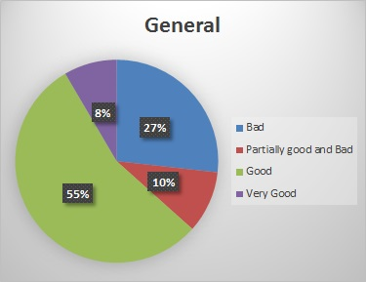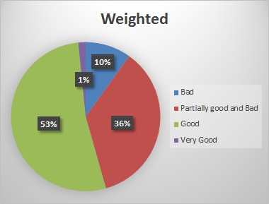
Figure 15: Sewer network condition in West bank and Gaza
Many of the sewer networks are old and poorly maintained, which is the cause of frequent spillage and leaks contaminating the surrounding areas. The number of recorded floods in 2015 is 40294 flood. 50% of the WW SPs declares having a frequently sewer Manholes overflows.
33 WW SPs exposed their sewer network to maintenance at least once a year. The rest SPs do not have programed maintenance and only do maintenance based on complaints and/or emergence calls.

4.2 Wastewater Generated Quantity
There is no practical method to measure the wastewater generated and collected in the sewer network. It has been estimated and calculated to the most accurate number based on the water consumption and number of house connection. In West Bank and Gaza, the total quantity of wastewater collected in the sewer networks is 202,749,488 m³ in 2015.

4.3 Inventory of Wastewater network
The two Pie charts below in , show the start dates of the of the waste water service collection and treatment, a considerable percentage of the respondents said they have started the collection in 1970, 1999, 2004 While most of the respondents said they have started treatments after the year 2000.

Start Date of Wastewater Service | Wastewater Service
1950’s | Al Bireh, Nablus
1960’s | Anabta , Hebron
1970’s | Jenin City, Tulkarem City, Deir Sharaf, Qaqiliya City , Ramallah
1980’s | Sarra, Qalandiya, Rafah
1990’s | Bir Nabala, Qalandiya Camp, Beit Hanina, Anata, Al Judeira, Al Jib, An Nabi Samwil, Az Za'ayyem, Bethlehem, Al Fawwar Camp, Al 'Arrub Camp
2000’s | Zeita, Attil, Hajja, 'Izbat at Tabib, Izbat Salman, Khirbt Sir, Salfit, Bediya, Bani Zeid, Al Gharbiya, Ein Siniya , Dura El Qare, Jifna, Nahhalin, Nuba, Kharas, Deir Samit, Khanyounis
2010-2016 | Barta, Anza, Iktaba, Beit Dajan, Beit Hassan, Habla, Ramoun and Al Taypa, Jericho  Artas
Data is not available | El Far'a Camp, Baqa ash Sharqiya , Azmut, Beit Iba, Zawata, Jalazun Camp  Al Ram, Deir Elbalah, AlBuraij, AlMusadder, Almaghazi, Alnusairat, Om Elnaser, Jabalia, Biet Lahia, Bni Suhaila, Elshuka, AlQarara, Wadi Gaza, Alzawayda, Almughlaqa, Biet Hanon, AlZahra'a, Gaza

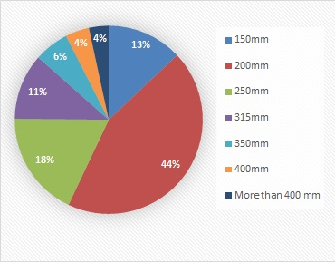
The total length of in operation sewer networks in West Bank and Gaza are 1,570,247 m and 1,508,500 m respectively.
The total 2,968,901 meter, various from different diameter starting from 150 mm. Figure 16 and Figure 17 shows the percentage and lengths of each diameter for West Bank. The diameter data has been extracted from available soft copy, SPs records.
In Gaza, there is no actual or estimated inventory for the diameter/ length of the sewer network. Only the total sewer network lengths were available.
Figure 16: Sewer network percentage diameter in West Bank

Figure 17: Sewer network length/diameter in West Bank
The total number of registered wastewater connection in West bank and Gaza are 115,970 and 123,570 respectively. Here registration means that each house connection has a record and a file in the SPs and/or the SPs has a rough estimation of the number of house connection. The rough estimation is coming from the fact that most of the SPs do not separate between the water and Wastewater services in term of billing.
Around 85% of the respondents said they had separate sewer collection system while near7% said they had partially combined system and only 4.11% reported having combined system, Figure 19 represent the differences of the collection system between Gaza and the West Bank.

Figure 18: Type of Sewer Collection
As a total, the investigated networks have been exposed to networks 1308 times, and the plants have been self-inspected by the service provider 4446 times and an average of 38% of the inhabitants was reported to use Percolation cesspits.
Only 34.5% of the respondent said there is an available soft copy for the sewer network and 37.5% said there is an available master plan for the network while only 29.2% said their sewer network has pumping station, regarding overflows, 56.4% of the respondents said the sewer network overflow frequently and those who reported overflow reported an average of 10.24% as a percentage of flooding with a total number of 40294 floods in 2015.

Figure 19: 2015 New House Connection in West Bank and Gaza
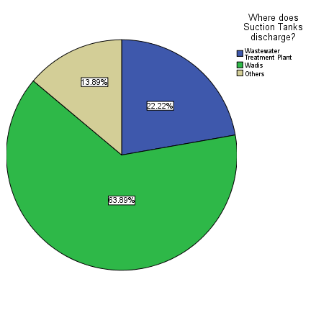
By dividing the total length of pipes and the total number of house connection, in West Bank each house connection confront13.54 of pipes. In Gaza, each house connection confronts 12.2 m. The total number of new house connection registered in 2015 is 5015. This number includes the normal yearly expansion of the WW house connection services. Figure 19 shows comparison of the number of new house connection in 2015.

Figure 20: Suction Tanks Discharge
shows the places where the suction tank is discharged, 64% of the respondents cleared the tanks gets discharged in the wadis, 22.22% said it gets discharged at the WWTP while the rest (14%) said they have other places for discharge.

100% of the respondents said the industrial factories had no pre-treatment.
But when asked about the way their institute use to get rid of wastewater flowing from the sewer network almost half of the respondents said it gets treated with WWTP, the rest have split in halves saying it either drains to the wadi without treatment or gets connected to Israeli connection point as seen in Figure 21.

Figure 21: Sewer Network Discharge

4.5 Pressurized Sewer network and Pumps
The total number of wet well/ booster pumps used in sewer network is 41 pumps. The total consumption of power in 2015 for these pumps is 1,121,400 kwh. These pumps are manly located and operated by the main WW SPs. Figure 22 shows the type and number of the sewer pumps in West Bank and Gaza.
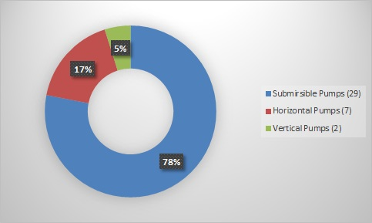
Figure 22: Sewer Network system in West Bank and Gaza
Most of these pumps are to pump the sewerage from a low point in the network into the gravity system. Figure 23 shows the location of the pumps within the communities and WW SPs.

Figure 23: Sewer Network pumps location in West Bank and Gaza

5. Wastewater Treatment Plants in West bank and Gaza

5.1 The Status of Wastewater Treatment in Palestine
In West Bank and Gaza, most of wastewater treatment plants (WWTP) provide only services within the municipal or urban areas, and several rural areas depending on the availability of budget and other resources (i.e., donors). In West Bank and Gaza, the WWTP in operation are 25 and 5 WWTP respectively.
In West bank 3 are not in operation yet. Figure 24Figure 25 shows the location maps of the WWTP in West bank and Gaza. In Palestine, WWTP has different treatment technologies. Figure 24 shows the types of Municipal Wastewater Treatment Plants in Palestine.
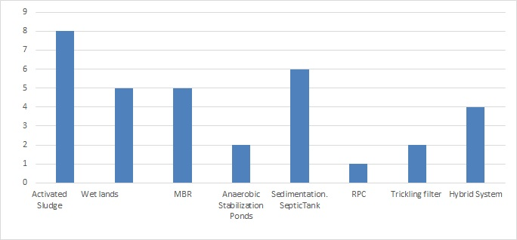
Figure 24: Types of Municipal Wastewater Treatment Plants in Palestine
Figure 24Figure 26 shows the weighted average, of the WWTP technology in term of treated wastewater quantity. From the Figures, hybrid systems (62.42% have been the most frequently used treatment process in the Palestinian areas (in Gaza Strip), Activated sludge systems (32.21%) are used widely in West Bank due to their efficiency. Membrane bioreactor systems (0.81%), on the other hand, are rarely used due to high-energy requirement and complexity on construction, operation and maintenance.
Constructed wetlands are commonly used in rural areas due to their simplicity and the availability of land. Existing treatment plants are in the small, medium and large scale size categories with the design capacities of <500-m3/d (0.54%) 500-2,000 m3/d (0.07%), 2,000-6,000 m3/d (5.7%), 6,000-10,000 m3/d (4.47%), 10,000-20,000 m3/d (31.10%), and >20,000 m3/d (58.1%).

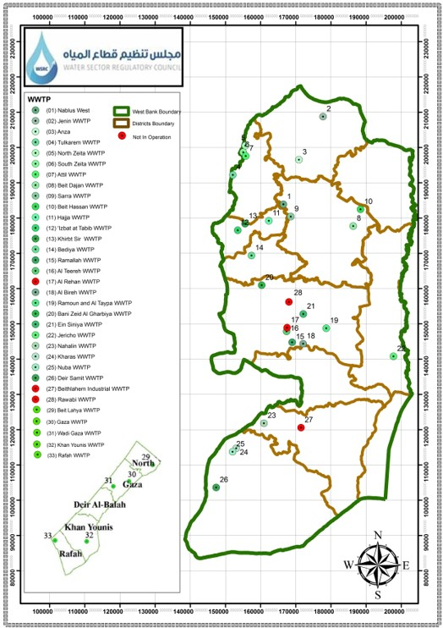
Figure 25: Key map for WWTP locations in West Bank and Gaza

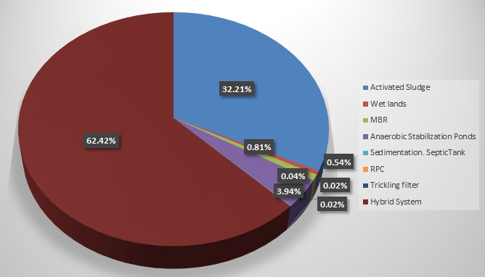
Figure 26: Weighted average of WWTP technologies in term of treated wastewater quantity

5.2 Treated Wastewater in Palestine
In West Bank, the total amount of treated WW is 9,380,430.54 m3/year which represent 35% of the wastewater collected in sewer network.
In Gaza, the total amount of treated WW is 44,712,500 m3/year which represent 39% of the wastewater collected in Gaza sewer network. shows the relation between the treated wastewater and the amount of wastewater collected by sewer network.
The total amount of treated WW in West Bank and Gaza is 54,092,030.54 m³/year. This represents 32% of the wastewater collected in sewer network.

Figure 27: Wastewater collected vs Wastewater treated in West bank and Gaza

5.3 Survey and baseline data of WWTP in Palestine

5.3.1 Activated Sludge WWTPs

5.3.1.1 Nablus West WWTP
Nablus West WWTP is an extended aeration activated Sludge plants, see Figure 28. It serves the western part of Nablus City including nearby villages such as part of Zawata, and Deir Sharaf villages. The Nablus West WWTP has a rated capacity of 14,000 m3/d. The flows during 2015 averaged at 10,850 m3/d. in 2015 the number of interruptions was zero.
The operation and maintenance cost for a treated cubic meter in 2015 is ~ 0.612 ILS/m3 (Water & Wastewater Department, Nablus Municipality) and classified as follows:
- Operating and Maintenance Cost (including Energy Cost) is ~ 0.408 ILS/m3;
- Administrative costs is ~ 0.204 ILS/m3;
Nablus Municipality is charging all water customers 0.50 ILS/m3 per water consumed for wastewater collection and treatment. Regardless if the customers are receiving the treatment service.
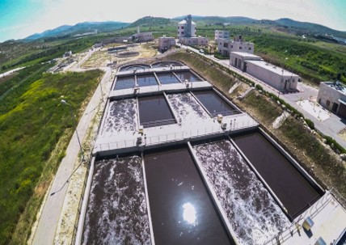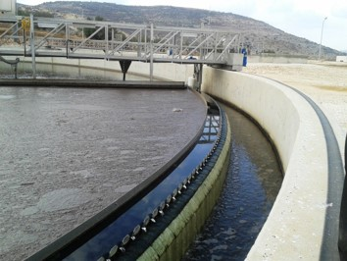
Figure 28: Nablus West WWTP (Source: http://wwtpal.com/)

5.3.1.2 Jericho WWTP
Jericho WWTP is an extended aeration activated Sludge plants, see Figure 29. It serves the Jericho City. The WWTP has a design capacity of 9,800 m3/d. The flows during 2015 averaged at 550 m3/d. In 2015 the number of interruptions was zero.
The operation and maintenance cost for a treated cubic meter in 2015 is ~ 0.65 ILS/m3 (Water & Wastewater Department, Jericho Municipality) and classified as follows:
- Operating and Maintenance Cost (including Energy Cost) is ~ 0.57 ILS/m3;
- Administrative costs is ~ 0.08 ILS/m3;
Jericho Municipality is charging all water customers 0.50 ILS/m3 per water consumed for wastewater collection and treatment.
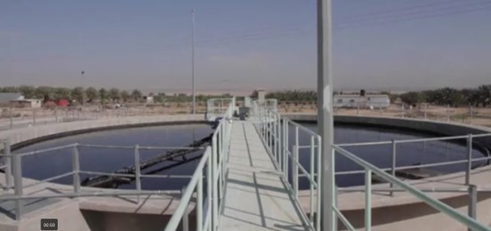
Figure 29: Jericho WWTP Overview

5.3.1.3 Al Bireh WWTP
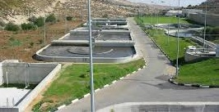
Al Bireh WWTP is an extended aeration activated Sludge plants, see Figure 30. It serves the Al Bireh City.
The WWTP has a design capacity of 5,750 m3/d. The flows during 2015 averaged at 6000 m3/d.
In 2015, a rehabilitation project funded by KFW was implemented. During this period, the WWTP was interrupted several times and was working in its full capacity. Figure 31shows photos of the rehabilitation which was implemented in 2015.
Figure 30: Al Bireh WWTP Overview
The operation and maintenance cost for a treated cubic meter in 2015 is ~ 0.55 ILS/m3 (Water & Wastewater Department, Al Bireh Municipality) and the total WW service cost 1.62 ILS/m3 classified as follows:
- WWTP Operating and Maintenance Cost (including Energy Cost) is ~ 0.55 ILS/m3;
- Human Resource Cost is ~ 0.35 ILS/m3;
- Energy Cost ~ 0.47 ILS/m3;
- Other operation cost ~ 0.254 ILS/m3
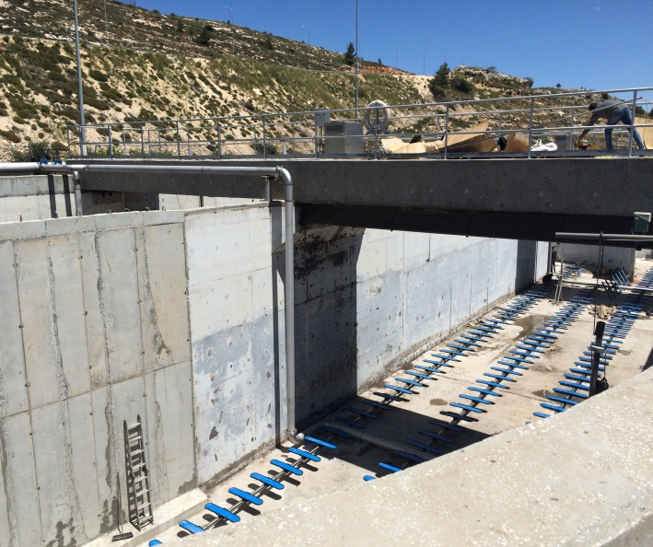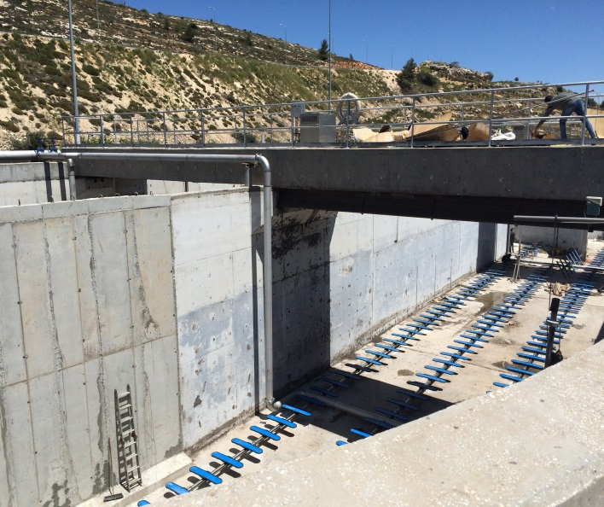
Figure 31: Al Bireh WWTP Rehabilitation project in 2015

5.3.1.4 Anza WWTP
Anza WWTP is a conventional activated Sludge plants, see Figure 32. It serves Anza Village. The WWTP has a design capacity of 240 m3/d. The flows during 2015 averaged at 200 m3/d serving more than 90% of the population of Anza.
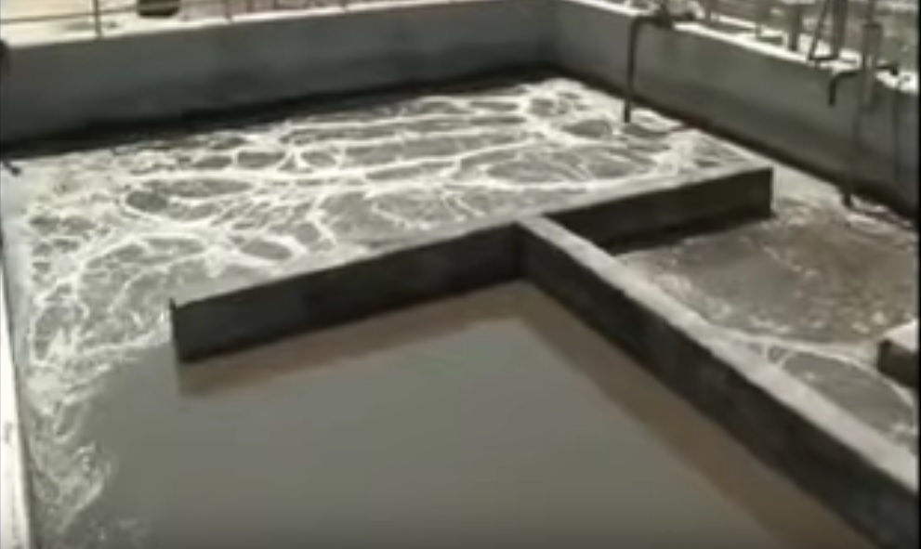
Figure 32: Anza WWTP Activated Sludge Treatment
The operation and maintenance cost for a treated cubic meter in 2015 is ~ 0.547 ILS/ and the total WW service cost 1.8 ILS/m3 classified as follows:
- WWTP Operating and Maintenance Cost is ~ 0.547 ILS/m3;
- Energy Cost ~ 0.49 ILS/m3
- Human Resource Cost is ~ 0.69 ILS/m3;
- Other operation cost ~ 0.073 ILS/m3;

5.3.1.5 Beit Dajan WWTP
Beit Dajan WWTP is a conventional activated Sludge plants. It serves Beit Dajan Village. The WWTP has a design capacity of 500 m3/d. The flows during 2015 averaged at 200 m3/d serving more than 80% of the population of Beit Dajan.
The operation and maintenance cost for a treated cubic meter in 2015 is ~ 0.547 ILS/ and the total WW service cost 1.84 ILS/m3 classified as follows:
- WWTP Operating and Maintenance Cost (including Energy Cost) is ~ 0.51ILS/m3;
- Human Resource Cost is ~ 1.23 ILS/m3;
- Other operation cost ~ 0.1 ILS/m3;

5.3.1.6 Ein Siniya WWTP
Ein Siniya WWTP is an Anaerobic Baffled Reactor (ABR) and Activated Sludge process. It serves Ein Siniyq, Jifna, Dura Al Qar’ and Al Jalazun Camp Beit.
According to 'Ein 'Siniya Village Council the WWTP has not been operated since 2009 due to lack of financial resources.

5.3.1.7 Nahalin WWTP
Nahalin WWTP is an extended aeration treatment process serves Nahalin town. The WWTP is designed to daily collect and treat 50 m3 of domestic wastewater generated. The wastewater is collected using a 7 m3 vacuum truck. The WWTP Operating and Maintenance Cost (including Energy Cost) is ~ 0.8ILS/m3.

5.3.1.8 Activated Sludge O&M Comparison

Figure 33, shows a comparison between the Activated Sludge treatment technology in term of operation and maintenance cost only.
The highest operation and maintenance cost is Jericho WWTP which can be justified that Jericho WWTP is working with only 5% of its capacity.

Figure 33: O&M Cost for Activated Sludge Treatment

5.3.2 Hybrid WWTPs

5.3.2.1 Gaza WWTP
Gaza WWTP is a hybrid system consists of anaerobic lagoons- attached biofilm, see Figure 34. It has a rated capacity of 60,000 m3/d. The flows during 2015 averaged at 55,000 m3/d. The operation and maintenance cost for a treated cubic meter in 2015 is ~ 0.5 ILS/m3 and administrative cost ~ 0.08 ILS/m3.
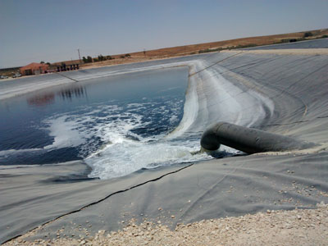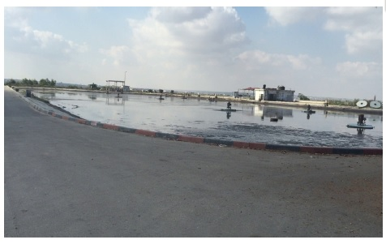
Figure 34: Aeration Pond at Gaza WWTP

5.3.2.2 Wadi Gaza WWTP
Gaza WWTP is a hybrid system consists of anaerobic pond. It has a rated capacity of 5,000 m3/d. The flows during 2015 averaged at 4,500 m3/d. The operation and maintenance cost for a treated cubic meter in 2015 is ~ 1.8 ILS/m3.

5.3.2.3 Rafah WWTP
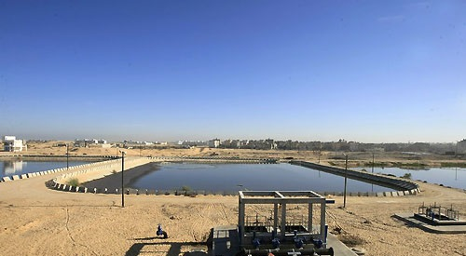
Rafah WWTP is a hybrid system consists of anaerobic lagoons- attached biofilm, see Figure 35. It has a rated capacity of 20,000 m3/d. The flows during 2015 averaged at 12,000 m3/d.
The operation and maintenance cost for a treated cubic meter in 2015 is ~ 2.0 ILS/m3. This includes the operation and energy cost.

Figure 35: Rafah WWTP

5.3.2.4 Hybrid System O&M Comparison
Figure 36, shows a comparison between the Hybrid System treatment technology in term of operation and maintenance cost only.
The highest operation and maintenance cost is in Rafah WWTP which can be justified with its design which include two pumping stations inside the facility which cause high energy consumption.

Figure 36: O&M Cost for Hybrid System Treatment

5.3.3 Anaerobic/ Aerobic Stabilization Ponds WWTPs

5.3.3.1 Tulkarem WWTP
Tulkarem WWTP is an anaerobic stabilization system plants. It has a rated capacity of 2,340 m³/d. the WWTP already reach its full capacity with flows during 2015 averaged at 2340 m³/d.
The operation and maintenance cost for a treated cubic meter in 2015 is ~ 0.33 ILS/m³ (not including the human resource cost) and classified as follows:
- Operating and Maintenance Cost (including Energy Cost) is ~ 0.33 ILS/m3;
- Human Resource Cost costs is ~ 0.56 ILS/m³;
- Other Operation Cost ~ 0.99 ILS/m³;
As total, the WW service cost is 1.88 ILS/m³.

5.3.3.2 Beit Lahya WWTP
Beit Lahya WWTP is an anaerobic stabilization system plants.
It has a rated capacity of 30,000 m³/d. the WWTP already reach its full capacity with flows during 2015 averaged at 30,000 m³/d.
The operation and maintenance cost for a treated cubic meter in 2015 is ~ 0.33 ILS/m³ (not including the human resource cost) and classified as follows:
- Operating and Maintenance Cost (including Energy Cost) is ~ 0.33 ILS/m3;
- Human Resource Cost costs is ~ 0.56 ILS/m³;
- Other Operation Cost ~ 0.99 ILS/m³;
As total, the WW service cost is 1.88 ILS/m³.

5.3.3.3 Jenin WWTP
Jenin WWTP is an aerated lagoons wastewater plant, see Figure 37. It has a rated capacity of 10,000 m³/d. The flows during 2015 averaged at 3,500 m3/d. in 2015 the number of interruptions was two.
The operation and maintenance cost for a treated cubic meter in 2015 is ~ 1.044 ILS/m³ (not including the human resource or administrative cost) and classified as follows:
- Operating and Maintenance Cost (not including Energy Cost) is ~ 0.83 ILS/m3;
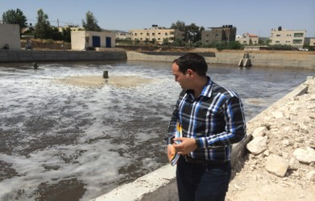
- Energy Cost ~ 0.214 ILS/m3;
- Human Resource Cost costs is ~0.152 ILS/m3;
- Other Operation Cost ~ 0.254 ILS/m3;
- Administrative Cost ~ 0.0092 ILS/m3;
As total, the WW service cost is 1.46 ILS/m³.

Figure 37: O&M Cost for Hybrid System Treatment

5.3.3.4 Khan Younis WWTP
Khan Younis WWTP is an aerated lagoons wastewater plant. It has a rated capacity of 25,000 m³/d. The flows during 2015 averaged at 22,000 m3/d. The operation and maintenance cost for a treated cubic meter in 2015 is ~ 2.0 ILS/m³.

5.3.3.5 Anaerobic/Aerobic Stabilization Ponds O&M Comparison
Figure 38, shows a comparison between the Anaerobic/Aerobic Stabilization Ponds technology in term of operation and maintenance cost only.

Figure 38: O&M Cost for Anaerobic/ Aerobic Stabilization Ponds

5.3.4 Membrane Bioreactors (MBR) WWTP

5.3.4.1 Alteereh –Ramallah WWTP
Alteereh WWTP is an activated sludge system with membrane bioreactor. It started the operation in 2014. The rated capacity of 2,000 m3/d with averaged flows during 2015 at 1200 m³/d. The operation and maintenance cost for a treated cubic meter in 2015 is ~ 2.1 ILS/m³ and classified as follows:
- Operating and Maintenance Cost (including Energy Cost) is ~ 1.1 ILS/m3;
- Administrative and Human Resource Cost costs is ~ 1.0 ILS/m3;

5.3.4.2 Not In operation MPR WWTP
Al Reehan neighborhood–Ramallah WWTP, Diplomatic neighborhood–Ramallah WWTP, Bethlehem Industrial Zone WWTP and Rawabi WWTP are yet not in operation.

5.3.5 Constructed Wet lands WWTPs

5.3.5.1 Beit Hassan WWTP
Beit Hassan WWTP is a constructed wet land wastewater plant, see Figure 39. It has a rated capacity of 200 m3/d. The flows during 2015 averaged at 115 m3/d. in 2015. It has a low-cost treatment technology with zero operation and maintenance cost for 2015. The cost for a treated cubic meter in 2015 is ~ 0.076 ILS/m³ (including the human resource cost).
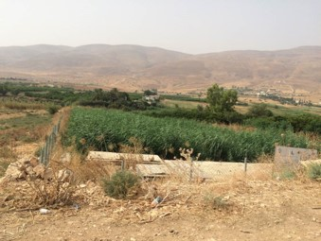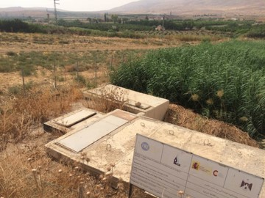
Figure 39: Beit Hassan Wet land WWTP

5.3.5.2 Hajja WWTP
Hajja WWTP is a constructed wet land wastewater plant. It has a rated capacity of 70 m³/d. The flows during 2015 averaged at 68 m3/d. in 2015. It has a low-cost treatment technology, the operation and maintenance cost for a treated cubic meter in 2015 is ~ 0.046 ILS/m³ for operation cost only. It WW service has other cost classified as follows:
- Other operation cost is ~ 0.587 ILS/m3;
- Administrative and Human Resource Cost costs is ~ 2.0 ILS/m3;

5.3.5.3 Zeita WWTP
Zeita WWTP is a constructed wet land wastewater plant. It has a rated capacity of 35 m³/d. The flows during 2015 averaged at 780 m3/d. in 2015. Zeita is connecting all the households to the WWTP, so not treatment is foreseen due to the overload.
The WW service for Zeit is ~ 0.1 ILS/m3.

5.3.5.4 Nuba and Kharas WWTP
Both Nuba and Kharas have a constructed wet land WWTP. The rated capacity are 150m3/day and 250m3/day respectively. The operation and maintenance cost for Nuba is 0.02 NIS/m3 and for Kharas is 0.013 NIS/m3.
The WW service cost for Nuba is 1.57m3/NIS and for Kharas 0.85 m3/NIS.

5.3.6 RPC WWTP
Taybeh and Ramoun WWTP is a rotating biological contactors (RBC) system. It has a rated capacity of 450 m3/d. The flows during 2015 averaged at 35 m3/day. in 2015 the number of interruptions was zero.
The operation and maintenance cost for a treated cubic meter in 2015 is ~ 2.3 ILS/m3. The cost of WW service JSC) is classified as follows:
- Operating and Maintenance Cost (including Energy Cost) is ~ 2.3 ILS/m3;
- Human Resource costs is ~ 7.6 ILS/m3;
- Other Operation Cost is ~ 0.5 ILS/m3.
These high figures can be justified by the fact that the WWTP design flow rate is only 7.7% of its full capacity.

5.3.7 Sedimentation Tank WWTP
Sedimentation tanks are located in Dir Samet, Attil, Izbet AL Tanib, Zeita Bedya, Bani Zeid Al Gharbiya. All of these WWTP are a very low technology. See Figure 40.

Figure 40: O&M Sedimentation Tank Cost

5.4 WWTP Interruption and Overflow
When asked about the amount of wastewater received at the WWTP only 22 respondents gave answers, and the answers ranged from (13-15000) Cubic meters/day, with a total of 42836 cubic meters per day. The same numbers of respondents answered the number of residents served by WWTP and the answers were (185-190000) with a total number of 468534.
50 respondents did answer the question about how much overflows occurred in 2015, 65% of those who answered said they didn’t have overflows at all and the rest were distributed as in the bar chart above. The amount of overflow was declared by only five respondents and the values were 2320, 2400, 42000, 50000, and 146000 cubic meters per year. Only 53 respondents answered the question asking about whether the respondents have WWTP, 52.8% of those who responded said they didn’t have while the rest said they do have one.
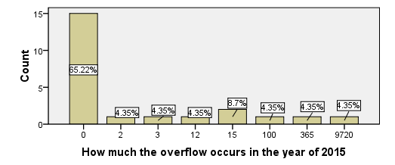
Figure 41: Number of Overflow Occurrences in 2015

Figure 42 shows the number of interruptions affected WWTP for the year of 2015 56.16% of the Respondents said the question is irrelevant, 12.33% didn’t answer 16.44% didn’t have interruptions, and the rest had (2- 365) interruptions.
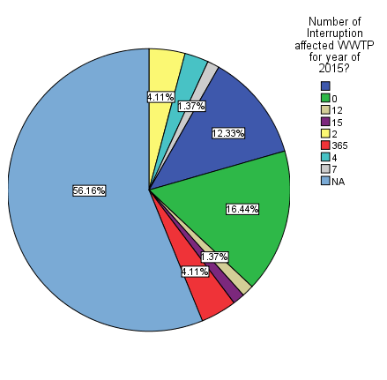

Figure 42: Number of Interruption affected the WWTPs

5.5 Sludge produced and utilized
The total amount of sludge produced in West Bank is 19,135 ton/year. Double these quantities are estimated to be produced in Gaza. 100% of the sludge is dumped into a landfill. and below shows the sludge management at West Bank WWTP.

Service Provider | Dry sludge produced (Ton/Year) | Utilized Sludge | Dry sludge to landfill
Jenin City | 2960 | 0 | 2960
Anza | 1.5 | 0 | 1.5
Tulkarem City | 2740 | 0 | 2740
Nablus | 5000 | 0 | 5000
Beit Dajan | 2 | 2 | 0
Hajja | 20 | 0 | 20
Bediya | 12 | 12 | 0
Ramallah | 1000 | 0 | 1000
Al Bireh | 7300 | 0 | 7300
Bani Zeid Al Gharbiya | 9 | 0 | 9
Jericho | 60 | 60 | 0
Nahhalin | 20 | 0 | 20
Nuba | 7 | 0 | 0
Kharas | 10 | 10 | 0
Total | 19,135 | 84 | 19,051

All of those who said they perform sludge treatments said they dump the dry sludge after treatment in a landfill, 50% of them said they dump it in a private land and the other half said they dump it in Zahret al Finjan landfill.
Only Jericho WWTP and Nablus West WWTP reported performing sludge quality measurements, and they both reported having automated control system for measurements. And they both reported 100% of the served wastewater received by the WWTP. All other SPs do not do sludge quality test due to the fact that it’s not allowed by the Palestinian standard to reuse.

5.6 Energy Consumption (KW/year)
Among those who have WWTPs, almost a half said they have zero energy consumption in KW/year, the rest are spread in Figure 43
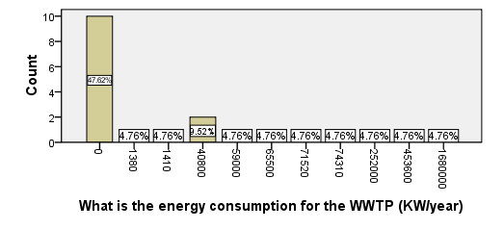
Figure 44: energy Consumption in West Bank WWTPs
The low cost/technology treatment plants do not consume any type of energy. This can be find in septic tank treatment plants and wet lands. The total amount of electricity consumed for treatment in West Bank in 2015 is 5,036,720 KW/Year. In Gaza, the total amount is around 19,112,388 KW/Year. See Figure 45.

Figure 45: Energy Consumption in West Bank WWTPs

6. Water Reuse in Palestine

6.1 Introduction
Although water resources are scarce in the West Bank and there is a great potential for treated wastewater reuse, the local experience and practice with treated wastewater reuse are very limited.
The volume of daily treated wastewater reuse is 3092m3/day. These quantities are in West Bank as the treated wastewater in Gaza is drained to the sea. Table 2 below shows the SPs which have reuse system.
Table 2: WW Service Provider Reuse System
Service Provider | Daily Treated WW (m3/day) | Reuse of Treated WW (m3/day) | %
Jenin Municipality | 3500 | 400 | 11.5
Anza Village Council | 80 | 75 | 93.75
Sarra Village Council | 210 | 120 | 57.2
Beit Hassan | 115 | 100 | 87
Hajja Village Council | 70 | 55 | 78.6
Sir Village Council | 15 | 12 | 80
Al Bireh Municipality | 6000 | 1800 | 30
Ramoun and Al Taypa JSC | 35 | 30 | 85.7
Jericho Municipality | 550 | 500 | 91
Nuba Village Council | 150 | 140 | 93
Kharas Village Council | 250 | 225 | 90

New reuse system is to be lunched soon for Nablus West WWTP. It is expected to reuse at least 90% of the treated wastewater received at the WWTP.

6.2 Reuse system
25% of the respondents responded the question asking about the volume of the treated waste water used in reuse, half of them reported 0 volume and the rest answers ranged from 12 – 1800 cubic meter per month with a total volume of 3092 cubic meter per month.
The next pie chart shows the reuse system used by the respondents, 87% of the respondents found the question irrelevant, 5.65% both used pressurized reuse system and by gravity reuse system and the rest used filling tanks. 24.7% of the respondents found the question asking about having an advanced treatment for reuse valid and all of them responded with NO, 9.72% of the respondents answered the question asking about the expenses of reuse of treated wastewater as of the end of 2015 and all their answers were ZERO, same result held for the cost for the operator or users association or farmers.
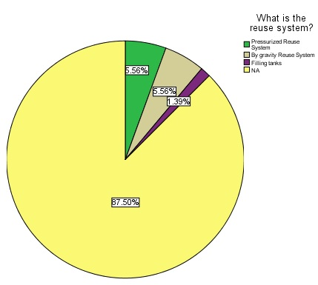
When asked if there was users association or the water was directly sold to the farmers, 91.78% thought the question was irrelevant, 6.85% said the water is sold directly to the farmers and the rest said there is an association called Marj Ubn Amer.
Figure 46 and Figure 48 shows the answers to whether farmers pay for using treated wastewater or not, 87.5% found the question n irrelevant, 11.11% said they don’t and the rest thought farmers do pay for using treated wastewater. The only respondent who said the pay for using treated wastewater reported paying .5 NIS/ Cubic meters is Jericho Municipality and they started by the year of 2016.
Figure 47: Reuse System for treated WW
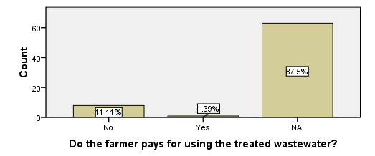
Figure 48: Treated Wastewater reuse and farmers

7. Tariff and Financial Status
This section describes and present the outcomes of the financial survey (questionnaire) applied on WW SPs.
41.8% responded to the question asking about the last time the respondent’s entity has implemented a tariff for waste water service and their answers are distributed as in Figure 49.
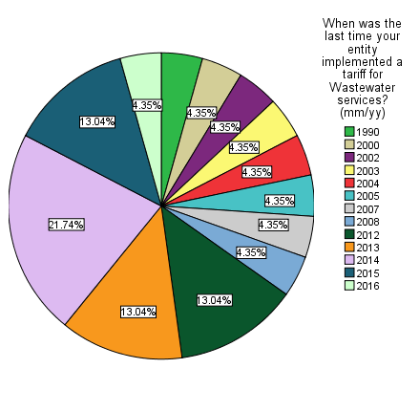

Figure 49: Treated Wastewater reuse and farmers

7.1 Wastewater Tariff
The WW tariff in Palestine is not organized or regulated. Out of 54 WW SPs in West Bank, only 29 WW SPs have a WW tariff service while 25 do not have a tariff service for the wastewater services. This is presented in Figure 50.
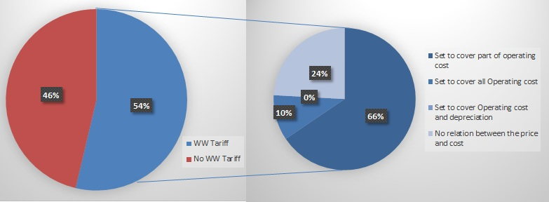
Figure 50: WW Tariff in West bank

66% of tariff is set to cover part of operating cost, 10% of tariff is set to cover all Operating cost and 24% has no relation between the price and cost. None of the WW SPs stated that the SPs Tariff covers all the operation cost. Below tables lists the WW SPs with no WW Tariff and do not collect or issue a WW bill. This is reflected on the raw data as the absence of the service tariff means that there is no service revenue, no WW bills and no account receivables balance for the wastewater
Table 3: WW Service Provider with no WW Tariff service
WW Service Provider | Wastewater Collected in network (m³/year) | WWTP Service | Waste Water Service
 |  |  | No. of House Connection
Jenin Municipality (WSSD) | 993,530 | √ | 2,029
Barta Municipality (ED) | 0 | X | 0
El Far'a Camp | 80,318 | X | 443
Tulkarem Municipality (WSSD) | 854,100 | √ | 1780
Iktaba Village Council | 1,825 | X | 3
Attil Municipality (ED) | 18,250 | √ | 70
Beit Hassan Village Council | 143,080 | √ | 150
'Izbat at Tabib Village Council | 9,855 | √ | 38
Ein Siniya Village Council | 5475 | √ | 35
Jalazun Camp | 127750 | X | 1119
Dura El Qare Village Council | 17520 | X | 100
Jifna Village Council | 2920 | X | 20
Bir Nabala Village Council | 215350 | X | 1050
Qalandiya Camp | 346750 | X | 1800
Beit Hanina Village Council | 12775 | X | 75
Anata Municipality (ED) | 511000 | X | 2600
Al Jib Village Council | 78475 | X | 325
An Nabi Samwil Village Council | 3650 | X | 22
Az Za'ayyem Village Council | 54750 | X | 350
Artas Village Council | 73000 | X | 500
Nahhalin Village Council | 18250 | √ | 0
Hebron Municipality (WSSD) | 4380000 | X | 16600
Deir Samit Village Council | 4927.5 | √ | 41
Al Fawwar Camp | 219000 | X | 1769
Al 'Arrub Camp | 273750 | X | 1920

The figures in the above tables represents that 31.5% of the wastewater collected in the sewer network in West bank were not billed (2015). And 32,839 WW house connections in West Bank are using the service without paying for service.
The tariff service differentiates between the WW SPs. Most of the small SPs have a fixed monthly tariff service (between 6 to 15 LIS). The big WW SPs bind the tariff with the water consumption (Such as in Nablus 0.5 ILS/m3 and AL Bireh 1.8 ILS/m3). Other WW SPs have a fixed yearly tariff service such as Bir Nabala with 60ILS.
The connection fees are also various between the different WW SPs. Most of them are related to the area of construction permits. Some are paid as a lump sum. Few are paid according to the actual cost of the house connection. Figure 51 shows the variation between method of calculation for the connection fees.

Figure 51: Connection Fees differentiation between the SPs

Regarding those who approve the last terrify for the waste water half of the respondents said the board of directors does 47.17% found the question irrelevant and the rest said the general manager or the mayor does.
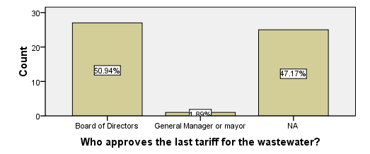
When asking if the customer receives an invoice for both water and waste water 48% of the respondents found the question irrelevant, 30.77% of them insured that the customers receive both values in the same invoice and the rest answered with NO.
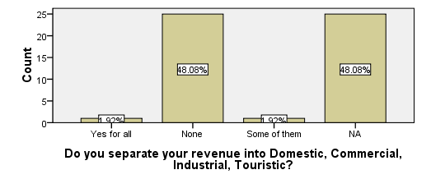
96% of the respondents split between not separating the revenue into domestic, industrial or touristic and not knowing if they do equally and the rest split between separating for all and for some, equally

7.2 Wastewater Revenue
WW SPs do not have categorization for the service revenue as all are paid as domestic use. The total Service revenue in West bank for the year of 2015 is 13,933,142 ILS. The total billed amount is 20,208,338 ILS. The collection rate is 68%. Figure 52 shows the total service revenue vs the total billed amount for the wastewater service in West Bank.

Figure 52: Total service revenue vs the total billed amount

The total revenue generated but not related to the services as connection fees, sales of tools, and others in West bank for 2015 is 14,185,541 ILS. Figure 53 shows the total connection fees for the wastewater service in West Bank.

Figure 53: Connection Fees Revenue

7.3 Wastewater Treatment Costs
Figure 54 present the cost classification of WW Service in West Bank. the total cost of human resources in the WW service is around 10,000,000 NIS, which represent 56% of the WW service cost, while other operation cost represents 22.5%.
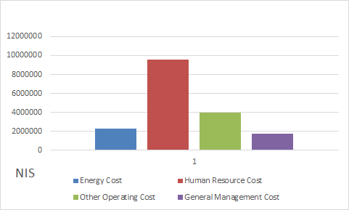
Figure 54: WW service classification in term of Cost

As total, the WW service cost on 2015 in West Bank is around 17,700,000 NIS and double this figure is Gaza. Figure 55 shows these costs as per selected SPs.
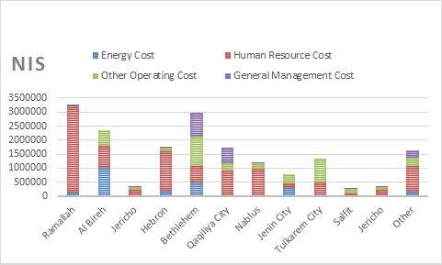
Figure 55: WW service classification for SPs in term of Cost

7.4 WW Assets
Total fixed assets cost of wastewater as of 31/12/2015 in West Bank is around 812,394,587.3 ILS. The Total assets of wastewater as 531,495, 391.48 ILS. See Figure 56.
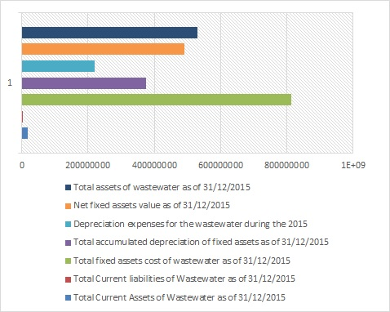
Figure 56: WW Assets in West Bank

8. Key Findings
- The data and information which was collected under the survey are enough to calculate all the indicators within the project.
- The total number of WW SPs in West Bank and Gaza is 73. This figure includes 105 community served by these service providers.
- The WW SPs includes 40 municipalities, 25 village Council, 5 Refugee Camps, 2 utilities and one JSC.
- In West Bank and Gaza, the WWTP in operation are 25 and 5 WWTP respectively.
- The total number of employees working in the field of WW within the SPs is 576.
- All the measurement of the Wastewater quality (Influent and Effluent) are either random or don by the SPs.
- Only Jericho WW SP provide a paid treated Wastewater. All other SPs with reuse system are given the treated wastewater for free.
- In West Bank and Gaza, the total quantity of wastewater collected in the sewer networks is 93,749,488 m³ in 2015.
- The total amount of treated WW in West Bank and Gaza is 54,092,030.54 m³/year. This represents 32% of the wastewater collected in sewer network.
- The total amount of sludge produced in West Bank is 19,135 ton/year. Double these quantities are produced in Gaza. the vast majority of the sludge is transferred into a landfill.

Annex – 1: Questionnaire
Wastewater Service Provides (SPs) Questionnaire
This questionnaire aims to collect data relating to the technical regulations, administrative, operational, and financial status of the wastewater service providers in the West Bank and Gaza in order to analyze and assess the current status of wastewater management.
- Questionnaire Information
1.1 | Questionnaire Serial No. (leave blank for Archive use)
1.2 | Field Surveyor Name
1.3 | District Name
1.4 | Questionnaire filling Date |  | Day |  |  | Month |  | Year
 |  |  |  |  |  |  |  | 2016
1.5 | Starting time & Ending time
1.6 | Questionnaire Data Entry Name
1.7 | Questionnaire Data Entry Date |  | Day |  |  | Month |  | Year
 |  |  |  |  |  |  |  | 2016
1.8 | Field Survey Supervisor |  | Eng. Osama Shaheen
- Respondent Information
2.1 | Respondent Name
2.2 | Respondent Position
2.3 | Contact Details |  |  | Mobile: ……………………….  Email: ………………………...
- General Information
3.1 | Type of SPs | Municipality |  | Village Council | Joint Service Council (JSC) |  | Utility |  | Others
3.2 | Name of SP
3.3 | Full office Address
3.4 | No. of council/BoD members
3.5 | Method of forming the Council/BoD |  |  | a. Election b. Nomination
3.6 | Services provided by the institute related to water and sanitation sector? |  |  | a. Wastewater collection,  b. Water  c. wastewater Treatment
3.7 | No. of communities served by the institute (list the name of these community)
- General Data

4.1 | What is the number of inhabitant served by your institute? Per service
4.2 | What is the Quantity of drinking water provided by the service provider (m³/month)?
4.3 | What is the average consumption rate (litter/capita/day)
4.4 | What is the number of domestic water customers

- Institutional data and Information
5.1 |  | Does your institute have an organization structure approved by the local government? | a. Yes b. No
5.2 |  | If Yes, kindly provide a copy to be attached and when it was approved | a. Attached b. Not attached  Approval Year………….
5.3 |  | Does your institute have a separate wastewater division | a. Yes b. No
5.4 |  | What are the main activities and tasks of the wastewater division? You can select more than one answer | a. Operate the wastewater network and facilities.  b. Maintenance of the wastewater network and facilities.  c. Operation and maintenance of WWTP  d. House connection licensing  e. Design plan and supervision of expansion of the sewer network  f. Public service  g. Collection of water charges and sewage
5.5 | wPe1, wPe2, wPe9 and wPe14 | What are the number of wastewater staff and qualifications? | Fill Table 1
5.6 |  | Are there any Strategic plans for the wastewater management | a. Yes b. No
5.7 |  | Is there cooperation and coordination between the SP and any entity (government - non-governmental organizations) and other sanitation services? | a. Yes ……………………………  b. No
5.8 |  | What are the administrative, institutional and technical requirements to promote and develop the capacities of municipal sewage management? | a. Development of regulations  b. Staff training and Capacity Building  c. Equipment and tools  d.  e.
5.9 |  | What are the main challenges for sewage management? | a. Lack of technical maintenance services after the expiry of the financing of the projects.  b. Failure to provide sufficient support from the local authorities to create a cost-recovery system  c. Ineffectiveness of fee collection mechanisms  d. Difficulties of the full recovery of the costs of operation and maintenance  e. Difficulty in obtaining licenses for infrastructure projects  Others: operational
5.10 |  | When was the wastewater service (collection/treatment) started
5.11 | wPe17 | What is the number of related training delivered annually?
5.12 | wOp1 | Do you have a complaint system? | - Yes. General Complaints system  - Yes. Special for Water and Wastewater.  - No.
5.13 | wOp1 and wQs19 | What is the number of complaints received in 2015? | …………………….., fill table 4
5.14 | wOp1 and wQs19 | What is the number of solved complaints in 2015?
5.15 | wOp1 | Do you have an emergency call for the wastewater system? | - Yes. General Complaints system  - Yes. Special for Water and Wastewater.  - No.
5.16 | wOp1 | What is the number of emergency calls received in 2015?

- Sewer Network Data

6.1 | wPh1- wPh4 | What is the amount of wastewater generated (collected, % treated, reused) (m³/day)?...........................  Estimated…………….. Measured…………….
6.2 |  | What is the number of wastewater connections?  Domestic ............................... Industrial………………Others ……….
6.3 | wQs16 | What is the number of new wastewater house connection in 2015?........................
6.4 | wPh1- wPh4, wQs1 | Percentage of population served by the sewer network? ............................%
6.5 |  | When was the sewer network constructed? .............................and it was expanded during……………………..
6.6 |  | Area served and/or irrigated with treated wastewater? ......................................................  Type of reuse ....................
6.7 |  | What is the condition of the existing sewer network?  a. Very Good b. Good c. Bad d. Partially good and Bad
6.8 |  | In case the answer is c or d, the reasons are?  - Old sewer Network b. Small pipe diameter  c. Wastewater leak from the sewer network d. Insufficient sewer system  Others
6.9 |  | If yes, do these industrial factories has a pre-treatment? a. Yes b. No c. Partially Yes
6.10 |  | What are the ways to get rid of wastewater flowing from the sewer network?  a. Drains to the Wadi without treatment b. Treated with a WWTP  c. Others ………………………………
6.11 |  | Type of Sewer Collection System?  a. Separate System b. Partially Combined, ………..…%  c. Combined System
6.12 | wOp1 | What is the number of times that all the network is exposed to maintenance? ...........
6.13 | wOp1 | What is the number of times that the service provider self-inspected the plant? …………
6.14 |  | Number of Inhabitants using Percolation Cesspits?............................
6.15 |  | What is the total length of the sewer network (km)?.........................., Fill Table (2)
6.16 |  | Availability of a soft copy for the sewer network?  a. Yes b. No , If yes attached
6.17 |  | Availability of a master plan for the sewer network?  a. Yes b. No , If yes attached
6.18 | (wPh8-wPh10) | Does the sewer network has pumping station?  a. Yes b. No , If yes fill table 3
6.19 |  | Do Sewer Manholes overflows frequently?  a. Yes, Percentage flooded …………and number of floods in 2015 ……………  b. No
6.20 |  | Where does Suction Tanks discharge?  a. Wastewater Treatment Plant b. Wadis c. Others, Mention ……………
6.21 |  | Current Organic Loading (Please state if it is measured or Estimates)  a. Measured, please fill table below b. Estimated, please fill table below.  c. Not available  Population Equivalent BOD (kg/d) TSS (kg/d) NH₃-N (kg/d) COD (kg/d) TP (kg/d) OIL & GREASE (kg/d)

- Wastewater Treatment Plant

7.1 |  | What is the amount of wastewater received at the WWTP (m³/day)?........................  Estimated Measured
7.2 | wQs2 | What is the resident population served by WWTP?......................
7.3 | WEn1 and WEn 4, | How much the overflow occurs in the year of 2015?..............................  How much is the amount of wastewater that overflow (m³)…………….
7.4 | WEn1 | Do you have a Wastewater Treatment Plant?  a. Yes, please fill table below. Population Served ……………………………  b. No  Name Year Constructed Population Served Design Flow Rate (m³/day) Actual Flow Rate (m³/day) in average
7.5 | wOp18 | What is the amount of wastewater treated at the WWTP (m³/day)?..........................  a. Estimated b. Measured
7.6 | wQS15 | Number of Interruption affected WWTP for year of 2015?  …………………………………….
7.7 | wOp18 | What is the energy consumption for the WWTP (KW/month)?..........................  a. Estimated b. Measured
7.8 |  | What is the Wastewater Treatment Plant technology?  a. Activated Sludge b. Wet lands c. MBR  d. Other………………...…………………………………………………..
7.9 |  | What is the Treatment Stages?  1. ………………...……………………… 2. ………………...………………………  3. ………………...……………………… 4. ………………...………………………
7.10 | wOp45- wOp50- | Pollutants removal efficiency of the WWTP  Pollutant Influent (mg/L) Effluent (mg/L) No. of testes in 2015 Remarks  BOD₅  COD  TN  TP as PO₄-P  TSS  CFU per 100 mL  pH  Comments: .................................................................................................................
7.11 | - | Do you perform any Sludge Treatment?  a. Yes b. No
7.12 | WEn6 | How much dry sludge does the WWTP produce per Year? ...………… (Ton/Year)  How much dry sludge utilized per Year? ...………… (Ton/Year)
7.13 | WEn9 | How do you take care of the dry sludge after treatment?  a. Dump it in a landfill,…………………. (Name of the landfill)  b. Reuse of the sludge. (notify that the reuse of sludge is not yet approved)
7.14 | WEn9 | How much dry sludge is transferred to the landfill? ……...…………(Ton/Year)
7.15 | wOp52 | Do you perform any sludge Quality measurements?  a. Yes, if yes fill below table b. No  Sludge Quality Parameter Concentration (Unit) No. of testes in 2015 Notes  Fecal Coliform  Salmonella sp. bacteria  Enteric Viruses  Viable Helminth Ova  Iron  Lead  Barium  Antimony  Mercury  Arsenic  Copper  Zinc  Chromium  Beryllium  Selenium  Nickel
7.16 | (wPh11-wPh12) | Are there any automation and control system for measurements (Scad,etc)  a. Yes b. No  if yes, what is the percentage of the served and wastewater received by the WWTP or pumped by the pumping stations? ....………….%………………….%

- Reuse

8.1 | WEn2, wPh1- wPh4 | What is the volume of treated wastewater(m³/month)?  a. Estimated b. Measured…...…….  What is the amount of treated wastewater used in Reuse (m³/month)? …...……..  a. Estimated b. Measured
8.2 |  | What is the reuse system?  a. Pressurized Reuse System  b. By gravity Reuse System  c. Filling tanks  d. Other………………...…………………………………………………..
8.3 |  | Do we have advanced treatment for reuse?  a. Yes b. No  If yes, What is the treatment System ………………...…………………………………………………..  . ………………...…………………………………………………..
8.4 |  | What are the expenses of reuse of treated wastewater as of 31/12/2015)?  ………………...…………………………………………………..  Distribution of the cost  Cost Item Amount (NIS)  1.  2. transport  3. Workers  4.  5.  What is the cost for the operator or users association or farmers?  .......................................................................................
8.5 |  | Is there a water users association or the water is sold directly to the farmers?  …………………………………………………………………………………
8.6 |  | Do the farmer pays for using the treated wastewater?  a. Yes b. No , If yes how much (NIS / cubic meter)?………………………..
8.7 |  | What is the collection rate of the fees of the reused treated wastewater?  Category Total revenues (NIS) Debt (NIS) Average collection rates for 2015 in %  Reuse
Table (1): Wastewater staff and qualifications (Indicator Codes: wPe1, wPe2, wPe9 and wPe14)
No. | Wastewater division* | Administrative/ technician/ operator* | Job title | Qualifications (wPe14) | Gender | years in service | Full time/part time
*Indicate if the employer is in the WWTP staff or the sewer network staff
Table (2): Sewer Networks lengths
Diameter (mm) | Length (m) | Material | Year of Construction | Construction Costs (NIS) | Maintenance Costs (NIS)

Table (3): Pumping Stations (wPh8-wPh10)
Type* | Flow (m3/hour) | Head (m) | Manufacturer | Year of Construction | Pump Power | Energy Consumption  (ILS per month)
* Wet/ Dry, Wet Well, Submersible, Horizontal, Vertical

Table (4): Complaints in 2015 (wOp1) and (wQs19)
Category of complaints* | Repetition | Average response times
* Flooding, smell, tariff, etc.

Question # One: -
When was the last time your entity implemented a tariff for Wastewater services?

Year ……… Month……….

السؤال الأول:-
متى هي اخر مرة تم عمل تعرفة للصرف الصحي؟
السنة ....... الشهر......
Question # Two: -
What is the wastewater house connection fees for the first time? And what is the average monthly services fees per connection?
connection fees……………….. Average Monthly fees……………….

السؤال الثاني:-
ما هي رسوم تركيب خدمة الصرف الصحي لأول مرة؟ ما هو المعدل الشهري لرسوم الصرف الصحي للاشتراك الواحد؟
رسوم التركيب ....... معدل الاشتراك الشهري ........

Question # Three: -
The tariff of the wastewater always sets and covers
- Set to cover part of operating cost
- Set to cover all Operating cost
- Set to cover Operating cost and depreciation
- No relation between the price and cost

السؤال الثالث:-
تعرفة الصرف الصحي تشمل و تغطي
- تغطي جزء من المصاريف التشغيلية
- تغطي كافة المصاريف التشغيلية
- تغطي المصاريف التشغيلية والاستهلاك
- لا علاقة بين سعر التعرفة والمصروف

Question # Four: -
Who approves the last tariff for the wastewater?
- Board of Directors
- General Manager or mayor
- Department manager
- Financial manager
السؤال الرابع:-
من قام بمصادقة التعرفة الحالية للصرف الصحي؟
- مجلس الادارة
- المدير العام او رئيس البلدية
- مدير الدائرة
- المدير المالي

Question # Five: -
Does the wastewater invoice part of the water invoice for the customer i.e. does the customer receive one invoice includes water and wastewater?
- Yes B. No
السؤال الخامس:-
هل تتضمن فاتورة المياه للمستهلك فاتورة الصرف الصحي أي ان المستهلك يستلم فاتورة واحدة للمياه والصرف الصحي؟
- نعم ب. لا

Question # Six: -
Do you>>> Are you separate your revenue into Domestic, Commercial, Industrial, Touristic?
- Yes for all B. None C. some of them
هل يتم تصنيف الايراد حسب النوع الى منزلي, تجاري, صناعي وسياحي؟
- نعم لجميع الانواع ب. لا ج. بعض ما ذكر
Question # Seven: -
Please fill the following table as of 31/12/2015 balances, please verify those numbers as per trail balance of wastewater department, if not separated please estimate to the most accurate.
السؤال السابع:-
الرجاء تعبئة الجدول التالي حسب ارصدة العام 2015 وبما يخص دائرة الصرف الصحي, او تقديرالبنود لاقرب قيم اذا لم تكن دائرة منفصلة.
No | Item البند | Description وصف البند | Amount NIS القيمة بالشيكل
01 | Service Revenue Domestic  ايراد الاشتراكات المنزلية | Revenue Generated from household connections against the service itself  الايراد الناتج عن الاشتراكات المنزلية
02 | Service Revenue Commercial  ايراد الاشتراكات التجارية | Revenue Generated from Commercial connections against the service itself  الايراد الناتج عن الاشتراكات التجارية
03 | Service Revenue Industrial  ايراد الاشتراكات الصناعية | Revenue Generated from industrial connections against the service itself  الايراد الناتج عن الاشتراكات الصناعية
04 | Service Revenue Touristic  ايراد الاشتراكات السياحية | Revenue Generated from Touristic connections against the service itself  الايراد الناتج عن الاشتراكات الصناعية
05 | Other Services Categories  ايراد اشتراكات اخرى | Revenue Generated from any other category rather than above  ايراد ناتج من اشتراكات اخرى غير التي ذكرت
06 | Total Services Revenue  ايراد كافة الاشتراكات | Sum of 01,02,03,04,05  مجموع البنود من 1-5
07 | Total of other Revenue of wastewater  ايرادات اخرى للصرف الصحي | Revenue generated but not related to the services as connection fees, sales of tools, and others  الايراد الناتج عن خدمة الصرف الصحي مثل رسوم التركيب, بيع الادوات, وايرادات اخرى
08 | Grand Wastewater Revenue generated  الاجمالي الكلي لايراد الصرف الصحي | Total of 06, 07 figures  مجموع البند 6, 7

Question # Eight: -
Please fill the following table as of 31/12/2015 balances, please verify those numbers as per trail balance of wastewater department.
السؤال الثامن:-
الرجاء تعبئة الجدول التالي حسب ارصدة العام 2015 وبما يخص دائرة الصرف الصحي
No | Item البند | Description وصف البند | Amount NIS القيمة بالشيكل
01 | Energy Cost  مصروف الطاقة | Electricity, fuel and other energy related to operation of wastewater.  اثمان كهرباء, محروقات واي تكلفة طاقة اخرى لازمة للتشغيل
02 | Human Resource Cost  مصروف الموارد البشرية | Includes salaries, wages, other benefits and allowances, provision for end of service compensation, annual bonus, overtime…..etc. (does not include salaries paid to retired staff)  تشمل الرواتب ,اجور العمال, اكراميات, مخصص نهاية الخدمة, مكافات, بدل عمل اضافي ... الخ (لا تشمل رواتب المتقاعدين)
03 | Other Operating Cost  مصاريف تشغيلية اخرى | All other cost related to operations as maintenance, vehicles,  تكاليف لازمة للتشغيل مثل صيانة تشغيلية والاليات
04 | General Management Cost | Shared cost i.e. applicable for all SPs exclude treatment
05 | Grand Total Cost  الاجمالي الكلي للمصاريف | Total of all above figures as of 31/12/2015  مجموع القيم السابقة كما هي في 31/12/2015

Question # Nine: - for Treatment only
Please fill the following table as of 31/12/2015 balances, please verify those numbers as per trail balance of treatment.
السؤال التاسع:- لمحطات المعالجة فقط
الرجاء تعبئة الجدول التالي حسب ارصدة العام 2015.
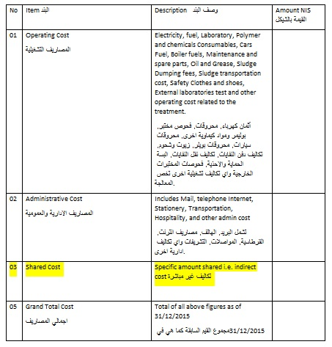
Question # Ten: - for Treatment only
How many cubic meters treated for year 2015? And what is the revenue generated if any
……………………………………….Cubic Meters ………………………………………….. NIS
السؤال العاشر:-
عدد الامتار المكعبة المعالجة خلال عام 2015؟ الايراد الناتج ان وجد
....................... متر مكعب ..................... شيكل

Question # Eleven: -
Are you separate your Account Receivables into water and wastewater?
- Yes B. No

السؤال الحادي عشر:-
هل يتم فصل الذمم المدينة الى ذمم مياه واخرى للصرف الصحي؟
- نعم ب. لا

Question # Twelve: -
Please fill the following table, please verify those numbers as per trail balance, if not separated, please estimate them to the most accurate
السؤال الثاني عشر:-
الرجاء تعبئة الجدول التالي حسب ارصدة العام 2015 وبما يخص دائرة الصرف الصحي, او تقديرالبنود لاقرب قيم اذا لم تكن دائرة منفصلة.
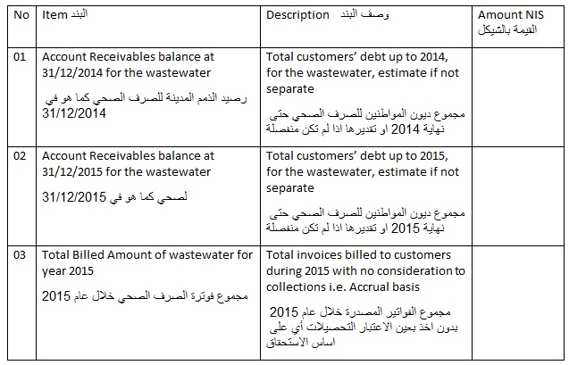

Question # Thirteen: -
Please fill the following table, please verify those numbers as per trail balance, if not separated, please estimate them to the most accurate
السؤال الثالث عشر:-
الرجاء تعبئة الجدول التالي حسب ارصدة العام 2015 وبما يخص دائرة الصرف الصحي, او تقديرالبنود لاقرب قيم اذا لم تكن دائرة منفصلة.
